Day in the Life of the Hudson River 10/14/21
Brooklyn Bridge Park (East) Pier 3, Brooklyn
RIVER MILE: 1.7
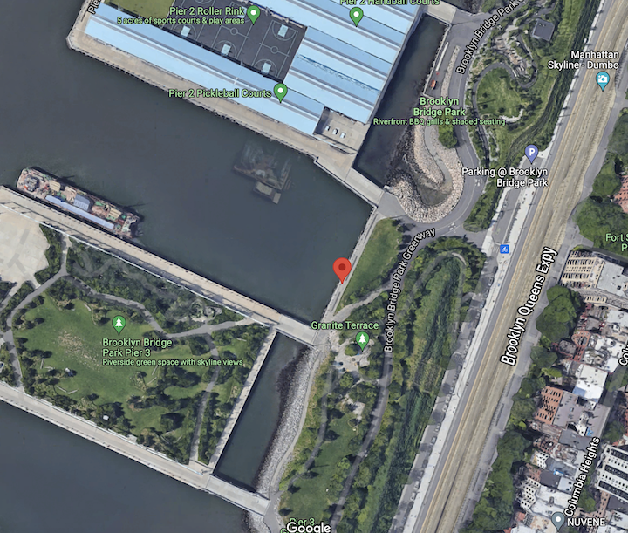
Salt Front: ~ 49
Bill Livingston & Brooklyn Friends School
12 students & 3 adults
Latitude 40 N & Longitude – 73 W
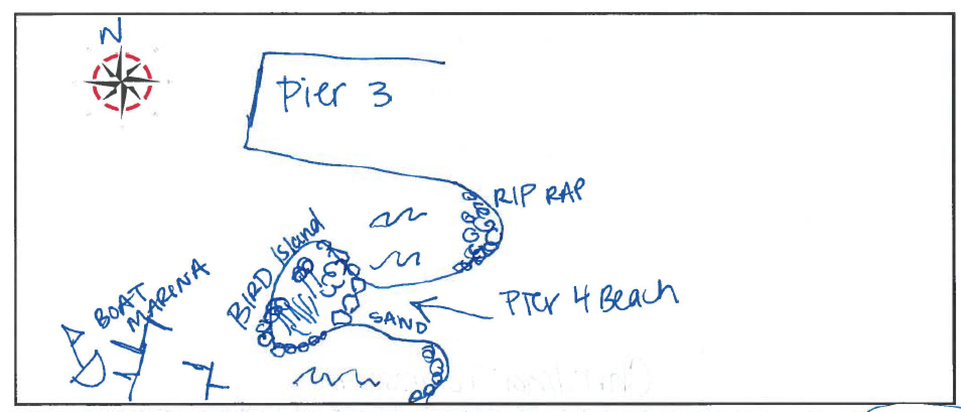
(site map for orientation from 2019 MS195 student)

Location: Pier 3 of Brooklyn Bridge Park, Brooklyn NY
Area: Mixed use park, marina south and park pier north of beach
Surrounding Land Use: 100% Urban/residential and park land
Sampling Site: By Oyster Restoration Site shoreside
Shoreline: Some riprap and pier
Water Depth:
Plants in area:
River Bottom description:
*NR = Not read/recorded
ITEM |  | Time |  | Reading |  |  |  | Comments
Physical
Air Temperature |  | 10:00 AM |  | 19.5 º C |  |  | NR
Wind Speed:  *Not taken well because of low wind |  | 10:00 AM |  | Anemometer  NR |  |  | Beaufort  NR | Direction  NR
Weather today |  | 10:00 AM |  | <25% cloud cover |  |  | No rain
Weather the past 3 days: |  | unseasonably warm - small rain three days before
Tides- |  | Time |  | Rising, Falling, Unchanged |  |  | Height (cm)
 |  | 9:00 AM-9:30 AM  10:00 AM- 10:15 AM |  | Falling  Rising |  |  | NR
Current- NR |  | Time |  | Cm/sec |  | Knots | North/South | Ebb/Flood/Slack
Water Temperature- |  | 10:00 AM |  | 19.7º C |  |  | 67.46º F
Turbidity- Short Sight Tube (60 cm) |  | 10:00 AM |  | >60 cm
Chemical
Salinity- Hydrometer |  | 10:00 AM |  | 23 ppt
Standardized Salinity- NR
DO – Lamotte Drop Count Kit |  | Time |  | Temp |  |  | ppm DO | % Saturation
 |  | 10:00 AM |  | 19.7 º C |  |  | 7.3 | 75%
pH – Probe |  | 10:00 AM |  | 6.5
Nitrates- LaMotte |  | 9:30 AM |  | 2 ppm
Phosphates- LaMotte |  | 9:30 AM |  | 0.4 ppm
Biological
Fish - |  | Number |  | Name |  |  | Length of longest | Length of smallest
*Oyster Cage
Fish Totals |  | TOTAL: 0 |  | Diversity: 0
Macroinvertebrates |  | Number |  | Name |  |  | Length of longest | Length of smallest
 |  | 3  numerous  several  4  numerous  1  1  2  4  1  1 |  | Mud Crab (black fingered)  Amphipods  Isopods  Oyster Drill  Round snails  Tube worm (pink)  Tube worm (black)  Sandworm  Grass Shrimp  Slipper snail  Sea Vase Tunicate |  |  | 2 cm  3 mm  2 cm  1 mm  N/R  2-3 mm  2 cm  3 cm  1 cm  colony - 9 cm² | 5 mm  1cm  2 cm
Macroinvertebrate Totals |  | TOTAL:17 plus |  | Diversity: 11
Sediment Core -NR
Length | H2S smell |  | Oxid Top |  | Oil |  | Grain Size | Other Features
Boats-NR
 | Time |  | Name |  | Color |  | North/Southbound | Light/Loaded
Commercial
Residential

